Stoke Park Primary School
Personal, Social, Health and Economic Education (PSHE) Policy

Approved by: | Governing Body | Date:
Last reviewed on:
Next review due by:
Guidelines
The DfE specified as part of its National Curriculum guidance that ‘All schools should make provision for personal, social, health and economic education (PSHE), drawing on good practice’. The review also detailed:

“PSHE remains an important and necessary part of all pupils’ education. We believe that all schools should teach PSHE, drawing on good practice, and have outlined this expectation in the introduction to the new National Curriculum” (Written Ministerial Statement: Review of Personal, Social, Health and Economic education, March 2013).

This Jigsaw PSHE policy is informed by existing DfE guidance on Sex and Relationships Education (Sex and Relationship Education Guidance, July 2000), preventing and tackling bullying (Preventing and tackling bullying: Advice for head teachers, staff and governing bodies, July 2013, updated 2017), Drug and Alcohol Education (DfE and ACPO drug advice for schools: Advice for local authorities, headteachers, school staff and governing bodies, September 2012), safeguarding (Working Together to Safeguard Children: A guide to inter-agency working to safeguard and promote the welfare of children, March 2013 and Keeping Children Safe in Education, 2018) and equality (Equality Act 2010: Advice for school leaders, school staff, governing bodies and local authorities, revised June 2014).

The Jigsaw Programme meets all the outcomes in the PSHE Association Programmes of Study, 2017.

Aims of the Jigsaw PSHE policy
The overarching aim for PSHE education is to provide pupils with the knowledge, understanding, attitudes, values and skills they need in order to reach their potential as individuals and within the community.

Pupils are encouraged to take part in a wide range of activities and experiences across and beyond the curriculum, contributing fully to the life of Stoke Park Primary and our local communities. In doing so they learn to recognise their own worth, work well with others and become increasingly responsible for their own learning. They reflect on their experiences and understand how they are developing personally and socially, tackling many of the spiritual, moral, social and cultural issues that are part of growing up.

They learn to understand and respect our common humanity; diversity and differences so that they can go on to form the effective, fulfilling relationships that are an essential part of life and learning.

At Stoke Park Primary we choose to deliver Personal, Social, Health Education using Jigsaw, the mindful approach to PSHE.

Objectives/Pupil learning intentions:
Jigsaw PSHE will support the development of the skills, attitudes, values and behaviour, which enable pupils to:
- Have a sense of purpose
- Value self and others
- Form relationships
- Make and act on informed decisions
- Communicate effectively
- Work with others
- Respond to challenge
- Be an active partner in their own learning
- Be active citizens within the local community
- Explore issues related to living in a democratic society
- Become healthy and fulfilled individuals

Jigsaw Content
Jigsaw covers all areas of PSHE for the primary phase, as the table below shows:

Term | Puzzle name | Content
Autumn 1: | Being Me in My World | Includes understanding my place in the class, school and global community as well as devising Learning Charters
Autumn 2: | Celebrating Difference | Includes anti-bullying (cyber and homophobic bullying included) and diversity work
Spring 1: | Dreams and Goals | Includes goal-setting, aspirations, working together to design and organise fund-raising events
Spring 2: | Healthy Me | Includes drugs and alcohol education, self-esteem and confidence as well as healthy lifestyle choices
Summer 1: | Relationships | Includes understanding friendship, family and other relationships, conflict resolution and communication skills
Summer 2: | Changing Me | Includes Sex and Relationship Education in the context of looking at change

How is Jigsaw PSHE organised in school?
Jigsaw brings together PSHE Education, emotional literacy, social skills and spiritual development in a comprehensive scheme of learning. Teaching strategies are varied and are mindful of preferred learning styles and the need for differentiation. Jigsaw is designed as a whole school approach, with all year groups working on the same theme (Puzzle) at the same time.

There are six Puzzles in Jigsaw that are designed to progress in sequence from September to July. Each Puzzle has six Pieces (lessons). Each Piece has two Learning Intentions: one is based on specific PSHE learning (covering the non-statutory national framework for PSHE Education but enhanced to address children’s needs today); and one is based on emotional literacy and social skills development to enhance children’s emotional and mental health. The enhancements mean that Jigsaw, the mindful approach to PSHE, is relevant to children living in today’s world as it helps them understand and be equipped to cope with issues like body image, cyber and homophobic bullying, and internet safety.

Every Piece (lesson) contributes to at least one of these aspects of children’s development. This is mapped on each Piece and balanced across each year group.

Jigsaw is taught every week in every class. Evidence of lessons are recorded in a floor book. Each week something is put in this book. This could be a photo, a copy of a piece of work, a printout of a smart board, or something else.

Differentiation/SEN
Jigsaw is written as a universal core curriculum provision for all children. Inclusivity is part of its philosophy. Teachers will need, as always, to tailor each Piece to meet the needs of the children in their classes. To support this differentiation, many Jigsaw Pieces suggest creative learning activities that allow children to choose the media with which they work and give them scope to work to their full potential. To further help teachers differentiate for children in their classes with special educational needs, each Puzzle includes a P-level grid with suggested activities for children working at each of those levels.

Safeguarding
Teachers need to be aware that sometimes disclosures may be made during these sessions; in which case, safeguarding procedures must be followed immediately. Sometimes it is clear that certain children may need time to talk one-to-one after the circle closes. It is important to allow the time and appropriate staffing for this to happen. If disclosures occur, our school safeguarding policy for managing disclosures is followed.

Monitoring and evaluation
The PSHE co-ordinator will monitor delivery of the programme through observation, book scrutiny and discussions with teaching staff to ensure consistent and coherent curriculum provision.

External contributors
External contributors from the community, e.g. health promotion specialists, school nurses, social workers, and community police and fire officers, make a valuable contribution to our PSHE programme. Their input should be carefully planned and monitored so as to fit into and complement the programme. Teachers MUST always be present during these sessions and remain responsible for the delivery of the Jigsaw PSHE programme.

The Learning Environment
Establishing a safe, open and positive learning environment based on trusting relationships between all members of the class, adults and children alike, is vital. To enable this, it is important that ‘ground rules’ are agreed and owned at the beginning of the year and are reinforced in every Piece – by using The Jigsaw Charter. (Ideally, teachers and children will devise their own Jigsaw Charter at the beginning of the year so that they have ownership of it). It needs to include the aspects below:
The Jigsaw Charter
- We take turns to speak
- We use kind and positive words
- We listen to each other
- We have the right to pass
- We only use names when giving compliments or when being positive
- We respect each other’s privacy (confidentiality)

Teaching Sensitive and Controversial Issues
Sensitive and controversial issues are certain to arise in learning from real-life experience. Teachers will be prepared to handle personal issues arising from the work, to deal sensitively with, and to follow up appropriately, disclosures made in a group or individual setting. Issues that we address that are likely to be sensitive and controversial because they have a political, social or personal impact or deal with values and beliefs include: family lifestyles and values, physical and medical issues, financial issues, bullying and bereavement.

Teachers will take all reasonable, practical steps to ensure that, where political or controversial issues are brought to pupils’ attention, they are offered a balanced presentation of opposing views. Teachers will adopt strategies that seek to avoid bias on their part and will teach pupils how to recognise bias and evaluate evidence. Teachers will seek to establish a classroom climate in which all pupils are free from any fear of expressing reasonable points of view that contradict those held either by their class teachers or their peers.

Values
Every term we have a ‘value’ which we focus on as a whole school. Our behaviour charts are based on these values and our values form an important part of the language we use at Stoke Park Primary.

Our values are:
- Confidence
- Friendship
- Creativity
- Kindness
- Respect
- Resilience

Science
Science is taught through the enquiry approach and the following attainment targets cover areas of the PSHE curriculum:
- Science Year 1: identify, name, draw and label the basic parts of the human body and say which part of the body is associated with each sense.
- Science Year 2: describe the importance for humans of exercise, eating the right amounts of different types of food, and hygiene.
- Science Year 3: identify that animals, including humans, need the right types and amount of nutrition, and that they cannot make their own food; they get nutrition from what they eat.
- Science Year 5: describe the changes as humans develop to old age.
- Science Year 6: recognise the impact of diet, exercise, drugs and lifestyle on the way their bodies function, describe the ways in which nutrients and water are transported within animals, including humans.

The Whole Curriculum
We believe that many of the skills and attitudes that we wish to develop through
PHSE are taught and demonstrated throughout the day at Stoke Park Primary. Pupils will have opportunities to develop their understanding of these issues through:

- School ethos
- Assemblies
- School trips
- Forest Schools activities
- Extra curricular activities
- Classroom and playground rules
- School Council and other areas of responsibility

Drug and Alcohol Education
Definition of ‘Drugs’:
This policy uses the definition that a drug is ‘A substance people take to change the way they feel, think or behave’ (United Nations Office on Drugs and Crime). The term ‘Drugs’ includes
- All illegal drugs
- All legal drugs including alcohol, tobacco and volatile substances which can be inhaled
- All over-the-counter and prescription medicines

Effective Drug and Alcohol Education can make a significant contribution to the development of the personal skills needed by pupils as they grow up. It also enables young people to make responsible and informed decisions about their health and well-being.

Jigsaw Drug and Alcohol Education Content
The grid below shows specific Drug and Alcohol Education learning intentions for each year group in the ‘Healthy Me’ Puzzle.

Year Group | Piece Number and Name | Learning Intentions  ‘Pupils will be able to…’
2 | Piece 3  Medicine Safety | understand how medicines work in my body and how important it is to use them safely  feel positive about caring for my body and keeping it healthy
3 | Piece 3  What Do I Know About Drugs? | tell you my knowledge and attitude towards drugs  identify how I feel towards drugs
4 | Piece 3  Smoking | understand the facts about smoking and its effects on health, and also some of the reasons some people start to smoke  can relate to feelings of shame and guilt and know how to act assertively to resist pressure from myself and others
 | Piece 4  Alcohol | understand the facts about alcohol and its effects on health, particularly the liver, and also some of the reasons some people drink alcohol  can relate to feelings of shame and guilt and know how to act assertively to resist pressure from myself and others
5 | Piece 1  Smoking | know the health risks of smoking and can tell you how tobacco affects the lungs, liver and heart  make an informed decision about whether or not I choose to smoke and know how to resist pressure
 | Piece 2  Alcohol | know some of the risks with misusing alcohol, including anti-social behaviour, and how it affects the liver and heart  make an informed decision about whether or not I choose to drink alcohol and know how to resist pressure
6 | Piece 2  Drugs | know about different types of drugs and their uses and their effects on the body particularly the liver and heart  be motivated to find ways to be happy and cope with life’s situations without using drugs
 | Piece 3  Alcohol | evaluate when alcohol is being used responsibly, anti-socially or being misused  tell you how I feel about using alcohol when I am older and my reasons for this

RSE and statutory duties in school
RSE plays a very important part in fulfilling the statutory duties all schools have to meet. RSE helps children understand the difference between safe and abusive relationships and equips them with the skills to get help if they need it. State-funded schools have responsibilities for safeguarding and a legal duty to promote pupil well-being (Education and Inspections Act 2006 Section 38). Some aspects of the relationship education curriculum are delivered in Jigsaw lessons throughout the year, although these tend to be weighted in the Term 5 lessons and part of the “Relationships” puzzle. During term 6, the “Changing Me” puzzle focuses on Sex and Relationship Education in the context of body changes and procreation.

Relationships Education
What does the DfE statutory guidance on Relationships Education expect children to know by the time they leave primary school?
Relationships Education in primary schools will cover ‘Families and people who care for me’, ‘Caring friendships’, ‘Respectful relationships’, ‘Online relationships’, and ‘Being safe’.
It is important to explain that whilst the Relationships Puzzle (unit) in Jigsaw covers most of the statutory Relationships Education, some of the outcomes are also taught elsewhere in Jigsaw e.g. the Celebrating Difference Puzzle helps children appreciate that there are many types of family composition and that each is important to the children involved. This holistic approach ensures the learning is reinforced through the year and across the curriculum.

Health Education
What does the DfE statutory guidance on Health Education expect children to know by the time they leave primary school?
Health Education in primary schools will cover ‘Mental wellbeing’, ‘Internet safety and harms’, Physical health and fitness’, Healthy eating’, ‘Drugs, alcohol and tobacco’, ‘Health and prevention’, ‘Basic First Aid’, ‘Changing adolescent body’.
It is important to explain that whilst the Healthy Me Puzzle (unit) in Jigsaw covers most of the statutory Health Education, some of the outcomes are taught elsewhere in Jigsaw e.g.emotional and mental health is nurtured every lesson through the Calm me time, social skills are grown every lesson through the Connect us activity and respect is enhanced through the use of the Jigsaw Charter.
Also, teaching children about puberty is now a statutory requirement which sits within the Health Education part of the DfE guidance within the ‘Changing adolescent body’ strand, and in Jigsaw this is taught as part of the Changing Me Puzzle (unit).

Sex Education
The DfE Guidance 2019 (p.23) recommends that all primary schools ‘have a sex education programme tailored to the age and the physical and emotional maturity of the pupils.
However, ‘Sex Education is not compulsory in primary schools’. (p. 23)
Schools are to determine the content of sex education at primary school. Sex education ‘should ensure that both boys and girls are prepared for the changes that adolescence brings and – drawing on knowledge of the human life cycle set out in the national curriculum for science - how a baby is conceived and born’.
At Stoke Park Primary School, we believe children should understand the facts about puberty and human reproduction before they leave primary school.
The grids below show a brief summary of the “Changing Me” Puzzle (unit) in Jigsaw with respect to what is taught relating to Puberty and Human Reproduction.
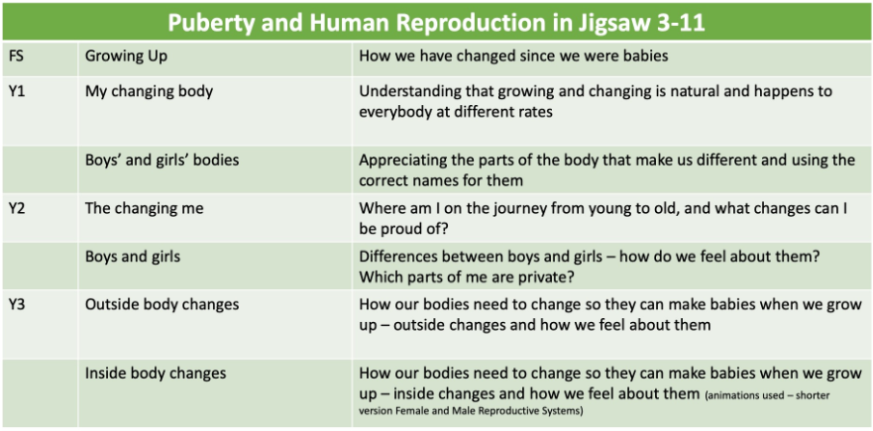
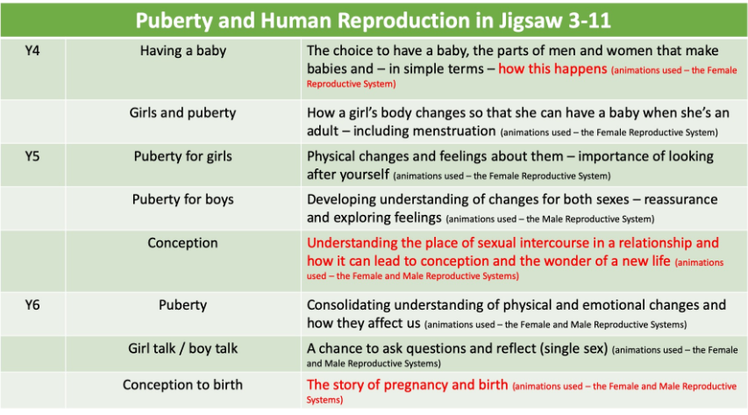
Effective RSE can make a significant contribution to the development of the personal skills needed by pupils if they are to establish and maintain relationships. It also enables children and young people to make responsible and informed decisions about their health and well-being.
The content in red on the grid above could be deemed as ‘Human Reproduction’ and if this is taught in PSHE, parents are able to request their children withdrawn from all or part of these lessons. However, if a similar unit is taught in Science, parents cannot exercise their right to withdraw.
Those parents/carers wishing to exercise this right are invited in to see the head teacher and/or RSE Co-ordinator who will explore any concerns and discuss any impact that withdrawal may have on the child.
Monitoring and Review
The Curriculum Committee of the governing body monitors this policy on an annual basis. This committee reports its findings and recommendations to the full governing body, as necessary, if the policy needs modification. The Curriculum Committee gives serious consideration to any comments from parents about the PSHE (RSHE) programme, and makes a record of all such comments.

Equality
This policy will inform the school’s Equalities Plan.
The DfE Guidance 2019 (p. 15) states, “Schools should ensure that the needs of all pupils are appropriately met, and that all pupils understand the importance of equality and respect. Schools must ensure they comply with the relevant provisions of the Equality Act 2010 under which sexual orientation and gender reassignment are amongst the protected characteristics.

At the point at which schools consider it appropriate to teach their pupils about LGBT (Lesbian, Gay, Bisexual, Transgender), they should ensure this content is fully integrated into their programmes of study for this area of the curriculum rather than delivered as a stand-alone unit or lesson. Schools are free to determine how they do this, and we expect all pupils to have been taught LGBT content at a timely point as part of this area of the curriculum”.

At Stoke Park Primary School we promote respect for all and value every individual child. We also respect the right of our children, their families and our staff, to hold beliefs, religious or otherwise, and understand that sometimes these may be in tension with our approach to some aspects of Relationships, Health and Sex Education.

