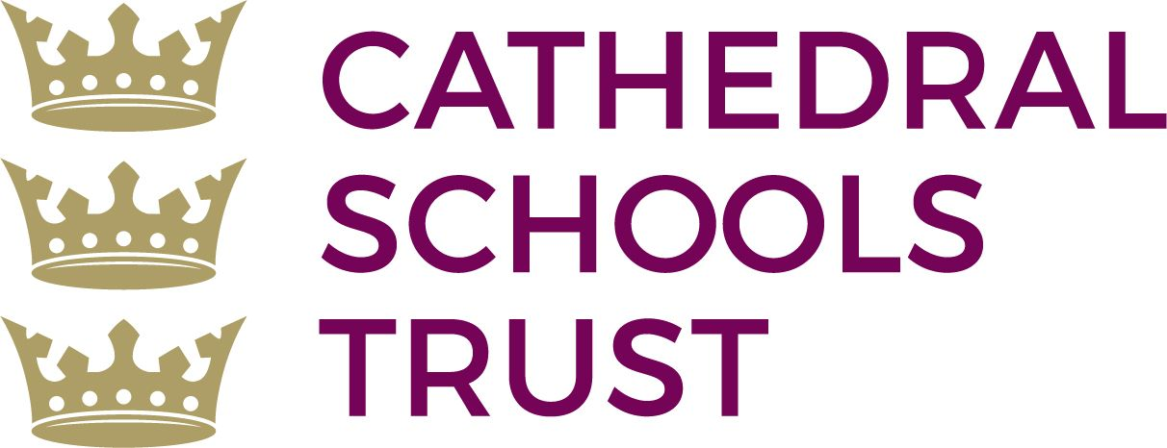

Cathedral Schools Trust
General Data Protection Regulation
Subject Access Request Form

This form may be used where an individual (Data Subject) wants to gain access to personal data that we hold about them. There is no charge for making a request. Please complete the form, enclosing appropriate identification and send it to the address at the end of the form.
Question 1 - Who is the Data Subject?
We recommend that you send your form and documents by a secure method, e.g. Recorded Delivery.

Question 1 - Who is the Data Subject?
Data Subject's full name
Date of Birth
Address

Post code
If the Data Subject has lived at this address for less than 2 years, please tell us their previous address
Post code
Telephone No.
E-mail address

Question 2 - What are your Personal Details? - What are your Personal etails?
- Are you the Data Subject?

Yes |  | No

If you answered 'Yes', go straight to Question 3 on page 2. Otherwise, please provide the information below.

Your full name
Address

Post code
Telephone No.

- If you are NOT the Data Subject, state your relationship to them.

What is your relationship to the Data Subject?

- If you are NOT the Data Subject, describe your entitlement to receive details of their Personal Data, and the written authority enclosed (e.g. from the Data Subject) which supports this entitlement.

Why are you entitled to their Personal Data?
What written authority have you enclosed?
Question 3 - How do you believe we process the Personal Data?
Question 3 - How do you believe we process the Data Subject's Personal Data?
Our search for information relating to the Data Subject will be based on the information provided below.

Any information, which will assist in searching for your personal information. | e.g.  - your personnel file;  - emails between ‘A’ and ‘B’ (between 1/6/16 and 1/9/16);  - CCTV camera situated at (‘E’ location) on 23/5/16 between 11am and 5pm;  Please delete these examples before completing the form
Dates for information requested | From |  | To
List relevant staff or departments who could assist

Question 4 - What documents can you send or produce to confirm the identity and address of the Data Subject??
We prefer to see the original documents for security purposes. We will return all original documents as soon as possible via recorded delivery.

If you deliver your documents in person we will return them to you after verification.

(a) You must confirm the Data Subject's identity by sending one of the documents listed below. Please tick the appropriate boxes to indicate which documents you have enclosed.
i) Full Valid Driving licence issued by a member state of the EC/EEA
ii) Birth Certificate or Certificate of Registry of Birth or Adoption certificate
iii) Full Valid Current Passport or ID Card issued by a member state of the EC/EEA or Travel Documents issued by the Home Office or Certificate of Naturalisation or Registration or Home Office Standard Acknowledgement Letter (SAL)

If the Data Subject's name is now different from that shown on the document you submit to confirm his/her identity, you must also supply original documentary evidence to confirm the data Subject's change of name e.g. Marriage Certificate, Decree Absolute or Decree Nisi papers, Deed Poll or Statutory Declaration.

(b) Applicants under 18 years old do not need to provide proof of address
(please tick if applicable)

(c) You must also confirm the Data Subject's address by sending us one of the
documents listed below. Please tick the appropriate boxes to indicate which documents you have enclosed.

i) Gas, electricity, water or telephone bill in the Data Subject's name for the last quarter
ii) Council Tax demand in the Data Subject's name for the last quarter
iii) Bank, building society or credit card statement in the Data Subject's name for the last quarter
iv) Letter to Data Subject from solicitor/social worker/probation officer in the last quarter
Formal Declaration

Formal Declaration
In exercise of the right granted to me under the terms of the UK General Data Protection Regulation, I request that you provide me with a copy of the Personal Data about the Data Subject which you process for the purposes I have indicated overleaf. I confirm that this is all of the Personal Data to which I am requesting access. I also confirm that I am either the Data Subject, or am acting on their behalf.

Signed
Print Name
Date

Make sure you have:
(a) completed this form;
(b) signed the declaration above;
(c) enclosed originals of identification documents.

Send them to:

Katie Connolly
Stoke Park Primary School
Brangwyn Grove
Lockleaze
Bristol
BS7 9BY

We recommend that you send your form and documents by a secure method, e.g. Recorded
Delivery.

You could also attend our school with your identification. Our staff will verify your form and send it to the relevant person.

Date

